Asset Log

Icons used
Image | Justification | Link
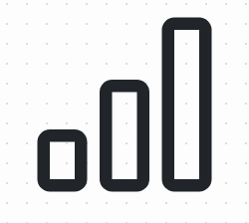 | This icon is displayed on the home screen and is better at attracting user attention than only using words | https://icons.getbootstrap.com/icons/bar-chart/
 | This is another home screen icon and is used to convey the idea of money to the user, the text directly below ensures the user that the site is free | https://icons.getbootstrap.com/icons/cash/
 | This icon is widely understood as being accessibility related and brings attention to the accessibility aspects of the website | https://icons.getbootstrap.com/icons/eyeglasses/
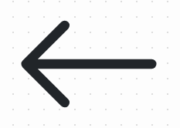 | This icon indicates to the user that they can go back to the previous page before they read the text, improving the user experience. | https://icons.getbootstrap.com/icons/arrow-left/
 | The next few items are for the Login/Sign up form.  The envelope indicates that this is an email field. | https://icons.getbootstrap.com/icons/envelope/
 | The lock represents something secure and indicates that this is a password field | https://icons.getbootstrap.com/icons/lock/
 | This icon shows that the field may contain something to identify them, like their name. | https://icons.getbootstrap.com/icons/person/
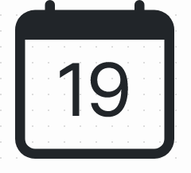 | This icon makes it obvious that the user is entering a date. As this is a sign up form, this would most likely be their date of birth | https://icons.getbootstrap.com/icons/calendar-date/

Other resources used
Resource Name | Justification | Link
Bootstrap 5.1 | Bootstrap is a powerful and easy to use CSS library that allows the developer to create a good looking and responsive website without having to spend time writing different media queries, animations and custom classes. | https://getbootstrap.com/
jQuery 3.6.0 | jQuery is very powerful and I have used it for many different things in this project, notably: page transitions and the AJAX task system. | https://jquery.com/
Fredoka font | I have used this font as it looks more friendly than the default bootstrap font while still being easy to read. | https://fonts.google.com/specimen/Fredoka
Stack Overflow

